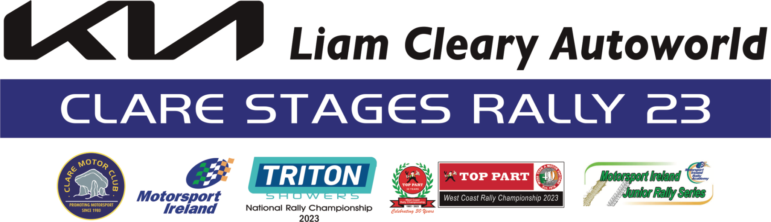

Press Release 1
The KIA Liam Cleary Autoworld Clare Stages Rally 2023
The Clare Motor Club is delighted to announce the return of our ever popular Clare Stages Rally after a four year absence. This year’s event will take place on Sunday 24th September 2023.
The Rally is based in our County town of Ennis and the entire rally base will be located at the Quin Road Business Park on the Quin Road on the outskirts of the town.
Rally Office/Recce Sign on and all documentation will take place in the offices of M Fitzgibbon Contractors Ltd.
Scrutiny and Service Park is just across the road only 200 metres away in the grounds of The Clare Marts Complex. Trailer Parking and Parc Ferme will be also located at the Mart Complex.
Long time Clare Motor Club supporter and friend Liam Cleary, the proprietor of the KIA Motor Dealership in Ennis has come on board as our main sponsor of the event which will be known as The KIA Liam Cleary Autoworld Clare Stages Rally.
Liam is no stranger to motorsport, developing his interest in the early 80s when he competed in Hot Rod Racing.
He has always been a great supporter of our club events including the Clare Stages Rally down through the years with his very generous sponsorship. In fact, Liam was responsible for sponsoring and bringing the late John Price and his co-driver Gareth Lloyd in their famous black Metro 6R4 to Ennis for the Woodchester Bank Clare Stages Rally in 1990, an event that they went on to win.
This year’s event is Round 7 of The Triton Showers Motorsport Ireland National Rally Championship, Round 5 of The Top Part West Coast Rally Championship and Round 8 of the Motorsport Ireland Junior Rally Series.
The Rally is a one day event consisting of three challenging, smooth tarmac stages which will be repeated three times, totalling 110kms. approximately and will transverse some of the most scenic parts of the Burren Landscape in North Clare.
The Stages consist of some fast and very technical sections and will no doubt provide an enjoyable challenge to all Competitors. There will be centralized servicing at the Ennis Mart Complex after stages 3 and 6.
COC for this year's event is Gerry O'Brien from Crusheen. Gerry has acted as Clerk of the Course for the last three Clare Stages Rallies which took place pre pandemic and he brings a wealth of Motorsport organizational experience with him.
The Pre Rally Launch for the 2023 KIA Liam Cleary Autoworld Clare Stages Rally 2023 will take place on Sunday September 3rd. at Liam's premises on the Kilrush Road in Ennis.
Online Entries will open on August 11th.
For Further Information Contact -
Event Secretary Margaret Mc Closkey - 087 2808159
Entries Secretary Lauren O’Keeffe – 087 9877169
COC Gerry O'Brien - 086-2766267
OUR SPONSOR
Liam Cleary acquired the Austin Rover Franchise in 1987 and opened his premises on the Limerick Road. A few months later the lsuzu Franchise was also acquired. The Limerick Road was ideally situated for sales and service of cars. However, the business was growing rapidly and just 3 years later in 1990 Liam Cleary had moved to a new premises on the Kilrush road and was now also the main Landover dealer for county Clare. The Landover Franchise grew rapidly over the coming years and Liam realized the premises could not accommodate the franchise. ln 1994 he purchased the old Interstretch Factory on the edge of town.
Work began in 1997 and the new showrooms was completed. The doors were opened as a main Landover and MG dealership in 2000. Liam Cleary Cars sales went through financial difficulties when the lrish economy went into a severe recession in 2008, sale of new luxury cars and used cars declined rapidly. ln 2008 and 2009, many people went back to their compact cars as they were less expensive to fuel and to purchase.
Liam decided to restructure the entire business and was approached by Kia in 2008 when he took
over the Kia Franchise and rebranded the company as Liam Cleary Autoworld.
ln 2010 a financial decision was made to hand back the Landover Franchise as it was no longer viable in County Clare.
Liam spent the next 10 years growing and expanding the Kia Franchise in County Clare. ln 2020 Liam Cleary began the renovations of the premises and added another showrooms. The premises had now become one of the largest showrooms in lreland while keeping the reputation of Liam Cleary Autoworld as a centre of excellence in selling and maintaining cars to the highest manufacturer standards.
Dermot Kelleher
PRO KIA Liam Cleary Autoworld Clare Stages Rally 23

